Task on RDS

1: Create MariaDB DB on EC2.
1. Launch EC2 Instance
- Go to AWS Console → EC2 → Instances → Launch Instance.
- AMI: Amazon Linux 2023
- Instance type: t3.micro
- Key pair: khan
- VPC: majeed-vpc
- Subnet: majeed-alb-subnet-2
- Auto-assign Public IP: Enabled
- Security Group: Allow SSH (TCP 22) from My IP.
- Launch the instance.
2. Connect to EC2
Connect to the EC2 instance using SSH from Git Bash.
3. Install MariaDB
sudo yum install mariadb105-server -y
4. Start MariaDB
sudo systemctl start mariadb
sudo systemctl enable mariadb
Check the service:
sudo systemctl status mariadb
The service showed:
Active: active (running)
5. Connect to MariaDB
sudo mariadb
MariaDB prompt:
MariaDB [(none)]>
6. Create Database
CREATE DATABASE companydb;
Verify:
SHOW DATABASES;
The companydb database was displayed.
7. Select the Database
USE companydb;
Output:
Database changed
8. Create Employees Table
CREATE TABLE employees (
id INT,
name VARCHAR(50),
age INT
);
Verify:
SHOW TABLES;
Output showed:
employees
9. Insert Data
INSERT INTO employees (id, name, age)
VALUES (1, 'Majeed', 25);
10. Verify Data
SELECT * FROM employees;
Output:
1 | Majeed | 25
11. Check Table Structure
DESCRIBE employees;
The table contains:
- id → INT
- name → VARCHAR(50)
- age → INT
Final Status
Task 1 — Create MariaDB DB on EC2: COMPLETED

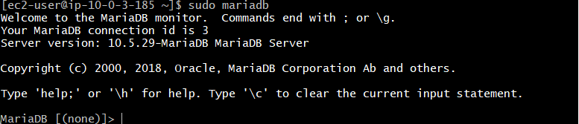
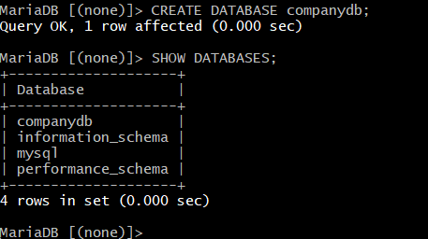
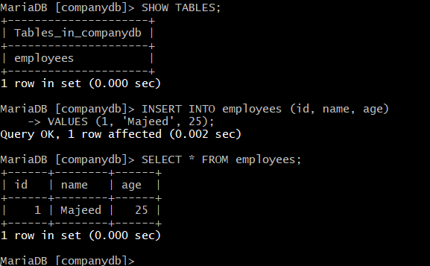
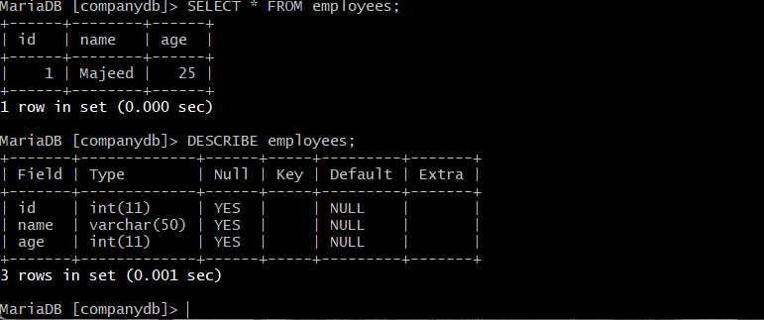

2: Insert some dummy data.
1. Connect to the Database
Make sure the companydb database is selected:
USE companydb;
2. Insert Dummy Data
INSERT INTO employees (id, name, age)
VALUES
(2, 'Rahul', 28),
(3, 'John', 32),
(4, 'Amit', 26),
(5, 'David', 30);
3. Verify the Data
SELECT * FROM employees;
The table displayed:
1 | Majeed | 25
2 | Rahul | 28
3 | John | 32
4 | Amit | 26
5 | David | 30
Result
5 employee records are now stored in the employee’s table.
Data was successfully inserted and retrieved.
MariaDB returned 4 rows affected with 0 duplicates and 0 warnings.
Final Status
Task 2 — Insert some dummy data: COMPLETED

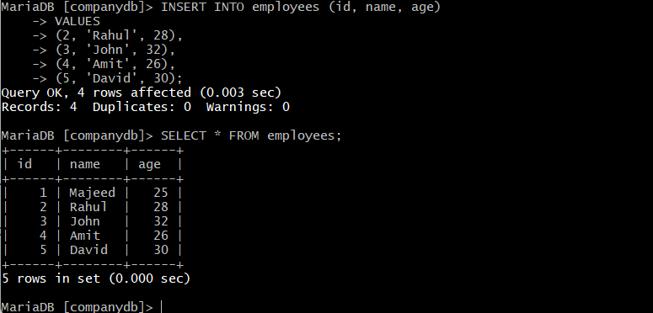

3: Take the backup of dummy data on EC2.
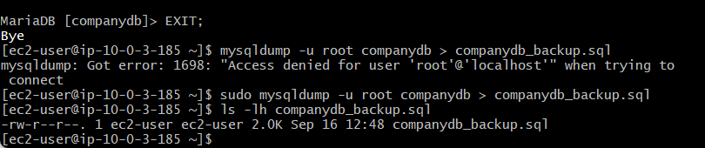
1. Exit MariaDB
EXIT;
2. Create Database Backup
Use mysqldump to export the companydb database:
sudo mysqldump -u root companydb > companydb_backup.sql
The backup was created successfully.
3. Verify the Backup File
ls -lh companydb_backup.sql
Output:
-rw-r--r--. 1 ec2-user ec2-user 2.0K Sep 16 12:48 companydb_backup.sql
Result
- Database: companydb
- Backup file: companydb_backup.sql
- Backup size: 2.0K
- Backup location: EC2 user's home directory
- Backup completed successfully.
Important Note
mysqldump exports the database structure and data into a SQL file. This file can later be used to restore the database.
Final Status
Task 3 — Take the backup of dummy data on EC2: COMPLETE

4: Launch MariaDB RDS instance.
Open AWS Console → RDS → Databases → Create database.
Select:
- Engine: MariaDB
- DB identifier: mariadb-rds
- VPC: majeed-vpc
- VPC security group: mariadb-ec2-sg
- Availability Zone: No preference
- RDS Proxy: Disabled
- Certificate authority: rds-ca-rsa2048-g1
2. Configure Monitoring
Under Monitoring:
- Database Insights: Standard
- Enhanced Monitoring: Disabled
- Log exports: None selected
3. Configure Additional Settings
- Initial database name: majeeddb
- DB parameter group: default.mariadb11.8
- Option group: default:mariadb-11-8
- Encryption: Enabled
- KMS key: Default aws/rds
- Automated backup: Enabled
- Backup retention: 1 day
- Backup window: No preference
- Backup replication: Disabled
- Auto minor version upgrade: Enabled
- Maintenance window: No preference
- Deletion protection: Disabled
Click Create database.
4. Verify the Database
Wait until the RDS database status changes from:
Creating / Configuring → Available
The database displayed:
mariadb-rds | Available | MariaDB | db.t4g.micro | us-east-1a
Result
MariaDB RDS instance was successfully created.
The database is running in the majeed-vpc VPC with the mariadb-ec2-sg security group.
The RDS instance status is Available.
Final Status
Task 4 — Launch MariaDB RDS instance: COMPLETED

Error:
Select majeed-vpc and check:
- Actions → Edit VPC settings
- Make sure:
  - ✅ Enable DNS resolution
  - ✅ Enable DNS hostnames
- Click Save changes
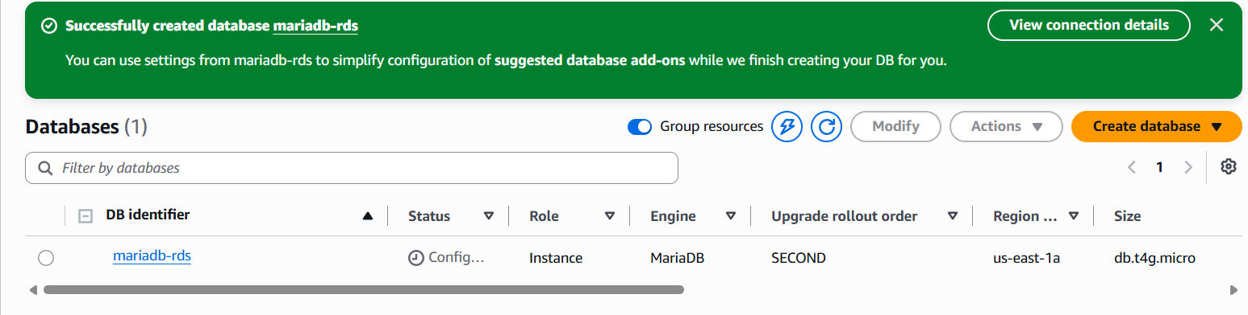
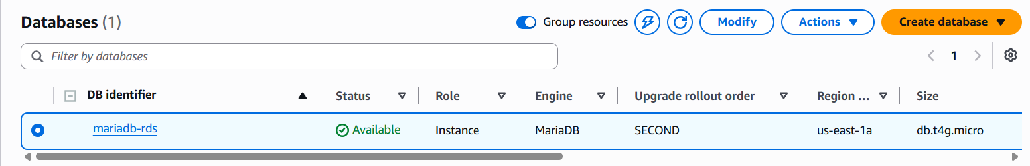
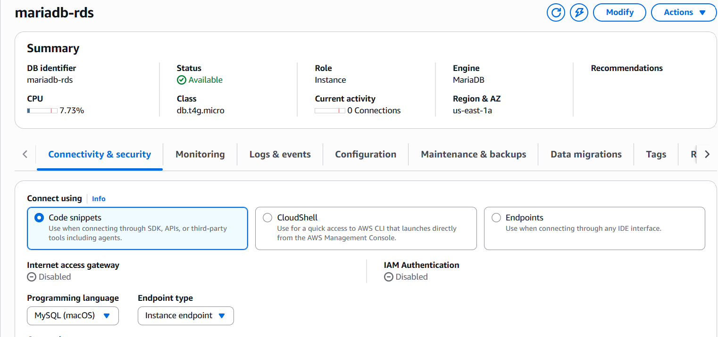

5: Migrate database from EC2 to RDS.
Step 1: Connect to EC2
Connect to the EC2 instance using SSH:
ssh -i "khan.pem" ec2-user@174.129.83.214
Step 2: Check the MariaDB database
Login to MariaDB:
sudo mysql
Select the database:
USE companydb;
Check the tables:
SHOW TABLES;
Verify the employee data:
SELECT * FROM employees;
The employees table contained 5 records.
Step 3: Create database backup
Exit MariaDB:
EXIT;
Create a database dump:
sudo mysqldump companydb > companydb.sql
Verify the backup file:
ls -lh companydb.sql
The companydb.sql file was created successfully.
- Step 4: Get RDS endpoint and configure security (important)
Go to:
AWS Console → RDS → Databases → mariadb-rds
Under Connectivity & security, select/copy the Endpoint:
mariadb-rds.cg5seoce4gqb.us-east-1.rds.amazonaws.com
Port:
3306
RDS details:
- Engine: MariaDB
- Port: 3306
- Publicly accessible: Yes
- VPC: majeed-vpc
Then go to the RDS security group and add an inbound rule:
Type: MYSQL/Aurora
Protocol: TCP
Port: 3306
Source: mariadb-ec2-sg
This allows the EC2 instance to connect to RDS.
Step 5: Connect from EC2 to RDS
From the EC2 instance:
mysql -h mariadb-rds.cg5seoce4gqb.us-east-1.rds.amazonaws.com -P 3306 -u admin -p --ssl
The RDS connection was successful.
Step 6: Create the database on RDS
Inside RDS MariaDB:
CREATE DATABASE companydb;
Exit:
EXIT;
Step 7: Import the database
Import the EC2 backup into RDS:
mysql -h mariadb-rds.cg5seoce4gqb.us-east-1.rds.amazonaws.com -P 3306 -u admin -p --ssl companydb < companydb.sql
Step 8: Verify the migration
Connect to RDS:
mysql -h mariadb-rds.cg5seoce4gqb.us-east-1.rds.amazonaws.com -P 3306 -u admin -p --ssl companydb
Check tables:
SHOW TABLES;
Verify the data:
SELECT * FROM employees;
The following 5 records were successfully migrated:
1 Majeed 25
2 Rahul 28
3 John 32
4 Amit 26
5 David 30
Result
Database migration from EC2 MariaDB to Amazon RDS MariaDB completed successfully.

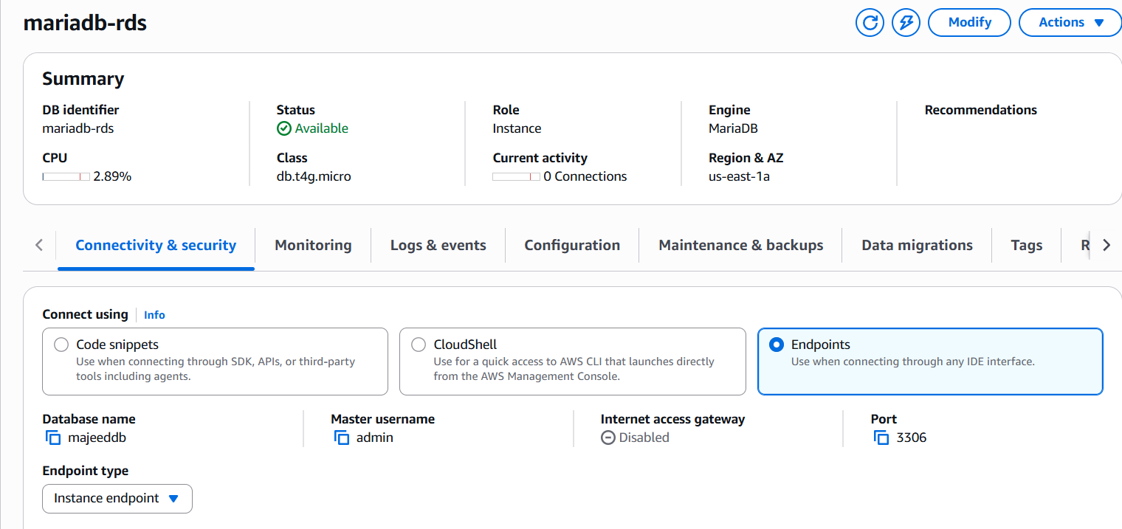
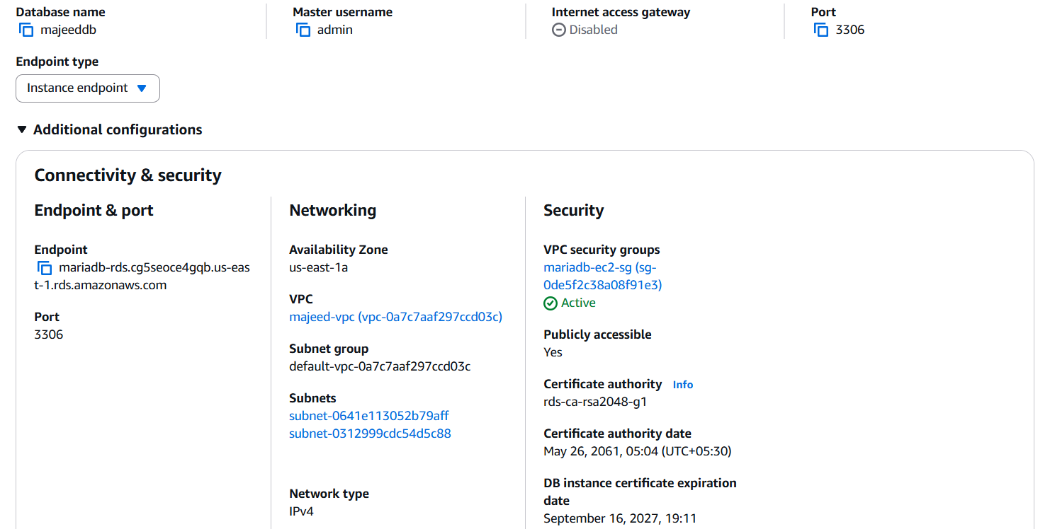
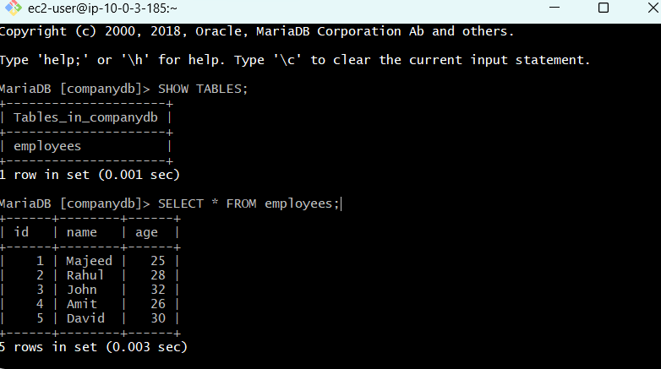

6: Install MySQL DB on EC2
- Created EC2 instance
  - Name: mysql-ec2
- Created security group
  - Name: mysql-ec2-sg
  - SSH: TCP 22 → My IP
  - MySQL: TCP 3306 → My IP
- Connected to EC2 using SSH.
- Searched available database packages:
sudo yum search mariadb
- Installed MariaDB:
sudo yum install mariadb118-server -y
- Started MariaDB:
sudo systemctl start mariadb
- Enabled MariaDB at system boot:
sudo systemctl enable mariadb
- Verified installation:
mysql --version
Output confirmed:
mysql from 11.8.8-MariaDB
Status: Task 6 completed successfully.
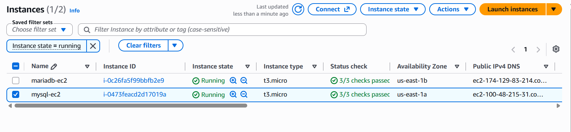
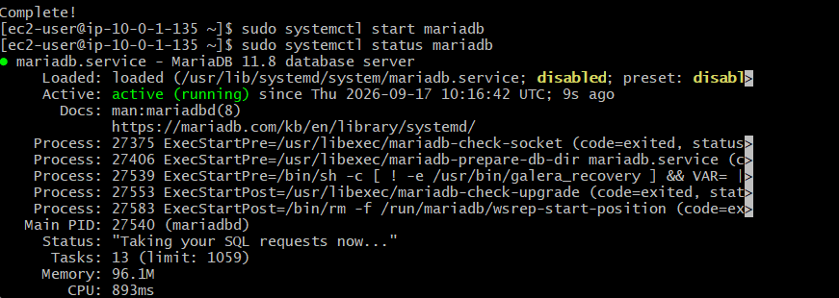
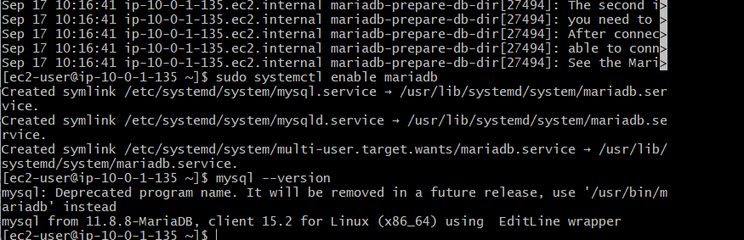

7: Launch MySQL RDS image.
- Opened AWS Console → RDS → Databases → Create database.
- Database creation method
  - Selected Full configuration
  - Template: Free tier
- Engine
  - Engine type: MySQL
  - Edition: MySQL Community
  - Engine version: MySQL 8.4.9
- Availability and durability
  - Selected Single-AZ DB instance deployment
- Settings
  - DB instance identifier: mysql-rds
  - Master username: admin
  - Created a master password
  - Authentication: Password authentication
- Instance configuration
  - Instance class: db.t4g.micro
- Connectivity
  - VPC: majeed-vpc
  - DB subnet group: default-vpc-0a7c7aaf297ccd03c2
  - Public access: Yes
  - VPC security group: mysql-ec2-sg
  - Availability Zone: No preference
- Storage
  - Storage type: General Purpose SSD (gp2)
  - Allocated storage: 20 GiB
- Database port
  - Port: 3306
- Monitoring
  - Database Insights: Standard
  - Enhanced Monitoring: Disabled
  - CloudWatch log exports: Disabled
- Additional configuration
  - Initial database name: companydb
  - Encryption: Enabled
  - KMS key: Default AWS RDS key
  - Automated backup: Enabled
  - Backup retention: 1 day
  - Backup replication: Disabled
  - Auto minor version upgrade: Disabled
  - Deletion protection: Disabled
- Clicked Create database.
- Waited until the RDS instance status changed to:
Available ✅
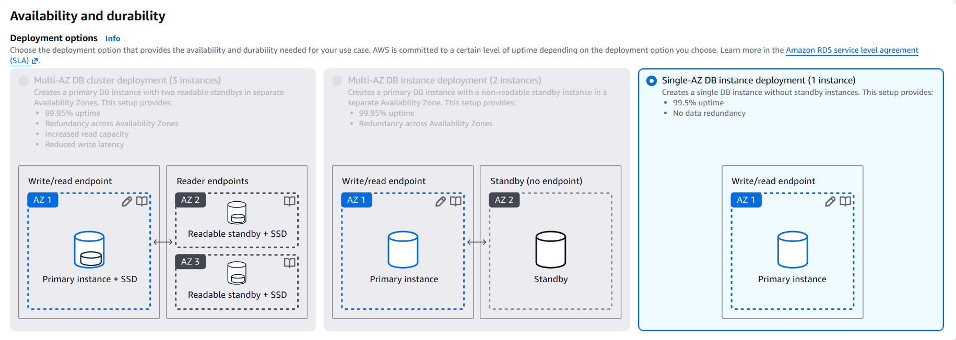Result
MySQL RDS instance mysql-rds was successfully launched.
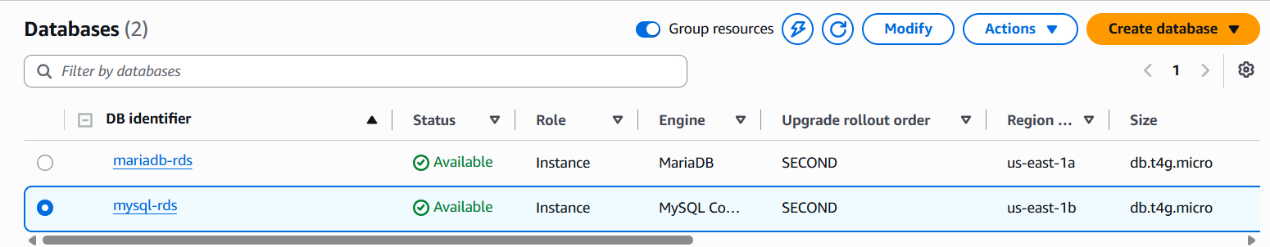
8: Configure Multi-AZ
- Opened AWS Console → RDS → Databases.
- Selected the RDS instance:
mysql-rds
- Clicked Modify.
- Opened Availability & durability.
- Checked Multi-AZ deployment.
- The option Create a standby instance was greyed out and could not be selected.
- Checked the RDS Configuration tab:
  - Multi-AZ: No
  - Secondary Zone: -
- Tried changing the instance class from db.t4g.micro to db.t3.micro, but the Multi-AZ option remained unavailable.
Result
Task 8: Not completed
Reason: Multi-AZ standby deployment was unavailable/disabled under the current AWS Free plan/account configuration.
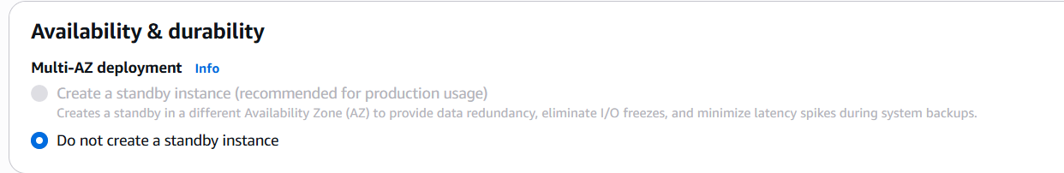

9: Take backup of DB and restore the DB.
A) A DB snapshot is a point-in-time backup of an RDS database. We can use the snapshot to restore the database as a new RDS DB instance
steps
- Open AWS Console → RDS → Databases.
- Select the database mysql-rds.
- Click Actions → Take snapshot.
- Enter snapshot name:
mysql-rds-backup
- Click Take snapshot.
- Go to RDS → Snapshots → Manual.
- Wait until mysql-rds-backup status becomes Available.
- Select mysql-rds-backup.
- Click Actions → Restore snapshot.
- Enter DB instance identifier:
mysql-rds-restored
- Select Single-AZ deployment.
- Select instance class:
db.t3.micro
- Keep VPC:
majeed-vpc
- Select the required security group:
mysql-ec2-sg
- Select Password authentication.
- Click Restore DB instance.
- Wait until mysql-rds-restored becomes Available.
result
- Backup created successfully: mysql-rds-backup
- Database restored as: mysql-rds-restored
- Original mysql-rds remains unchanged.
- Snapshot was used to create a new RDS DB instance.
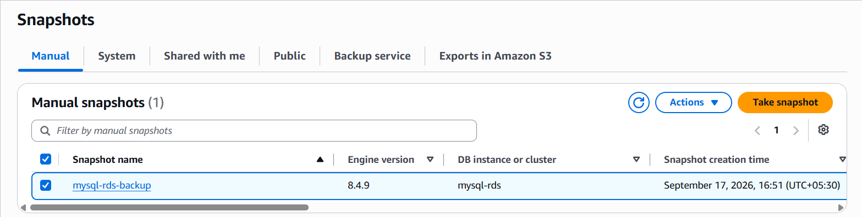

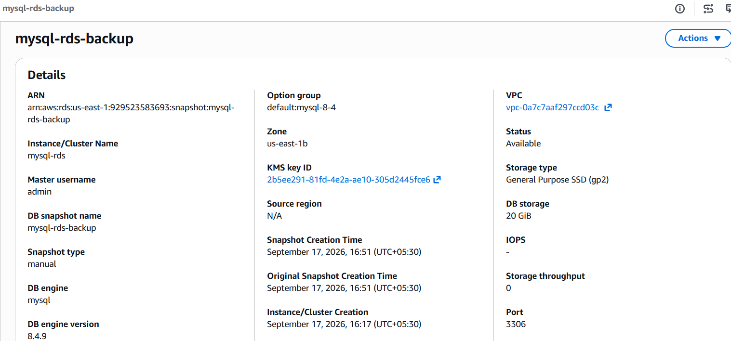
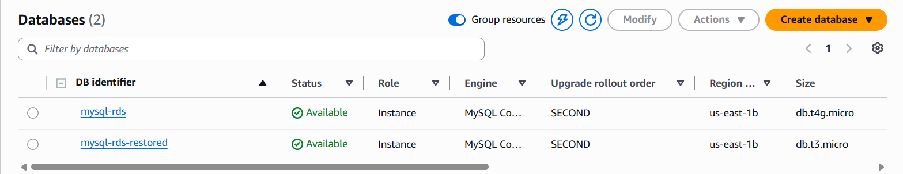

10: Create read replica.
A) A read replica is a read-only copy of an RDS database used to handle read traffic and reduce the load on the primary database.
steps
- Open AWS Console → RDS → Databases.
- Select the primary DB:
mysql-rds
- Click Actions → Create read replica.
- Enter DB instance identifier:
mysql-rds-read-replica
- Select instance class:
db.t4g.micro
- Select destination Region:
US East (N. Virginia)
- Keep storage:
  - General Purpose SSD (gp2)
  - 20 GiB
- Keep network type:
IPv4
- Select DB subnet group:
default-vpc-0a7c7aaf297ccd03c2
- Select Publicly accessible.
- Select VPC security group:
mysql-ec2-sg
- Leave Availability Zone as:
No preference
- Leave Enhanced Monitoring disabled.
- Keep encryption enabled with the existing KMS key.
- Keep Auto minor version upgrade disabled.
- Keep deletion protection disabled.
- Click Create read replica.
- Wait until mysql-rds-read-replica status becomes Available.
result
- Primary DB: mysql-rds
- Read replica: mysql-rds-read-replica
- Replica role: Replica
- Region: US East (N. Virginia)
- Instance class: db.t4g.micro
- Read replica created successfully.

